Smartsearch

Diagrama Entidade Relacionamentos
Grupo nº 3

Douglas Lira 11152100024
Gideone Salu 11111102449

Controle de Versão

Responsável | Modificação | Data
Gideone Salu | Criação do documento | 07/10/2018
Douglas Lira | Inserção do diagrama | 22/10/2018
Douglas Lira | Inserção do Script do BD | 03/11/2018
Gideone Salu | Inserção do Modelo Relacional | 04/11/2018
Índice

1. MER 4
2. Modelo Relacional 4
3. Script de Criação das Tabelas 4

MER

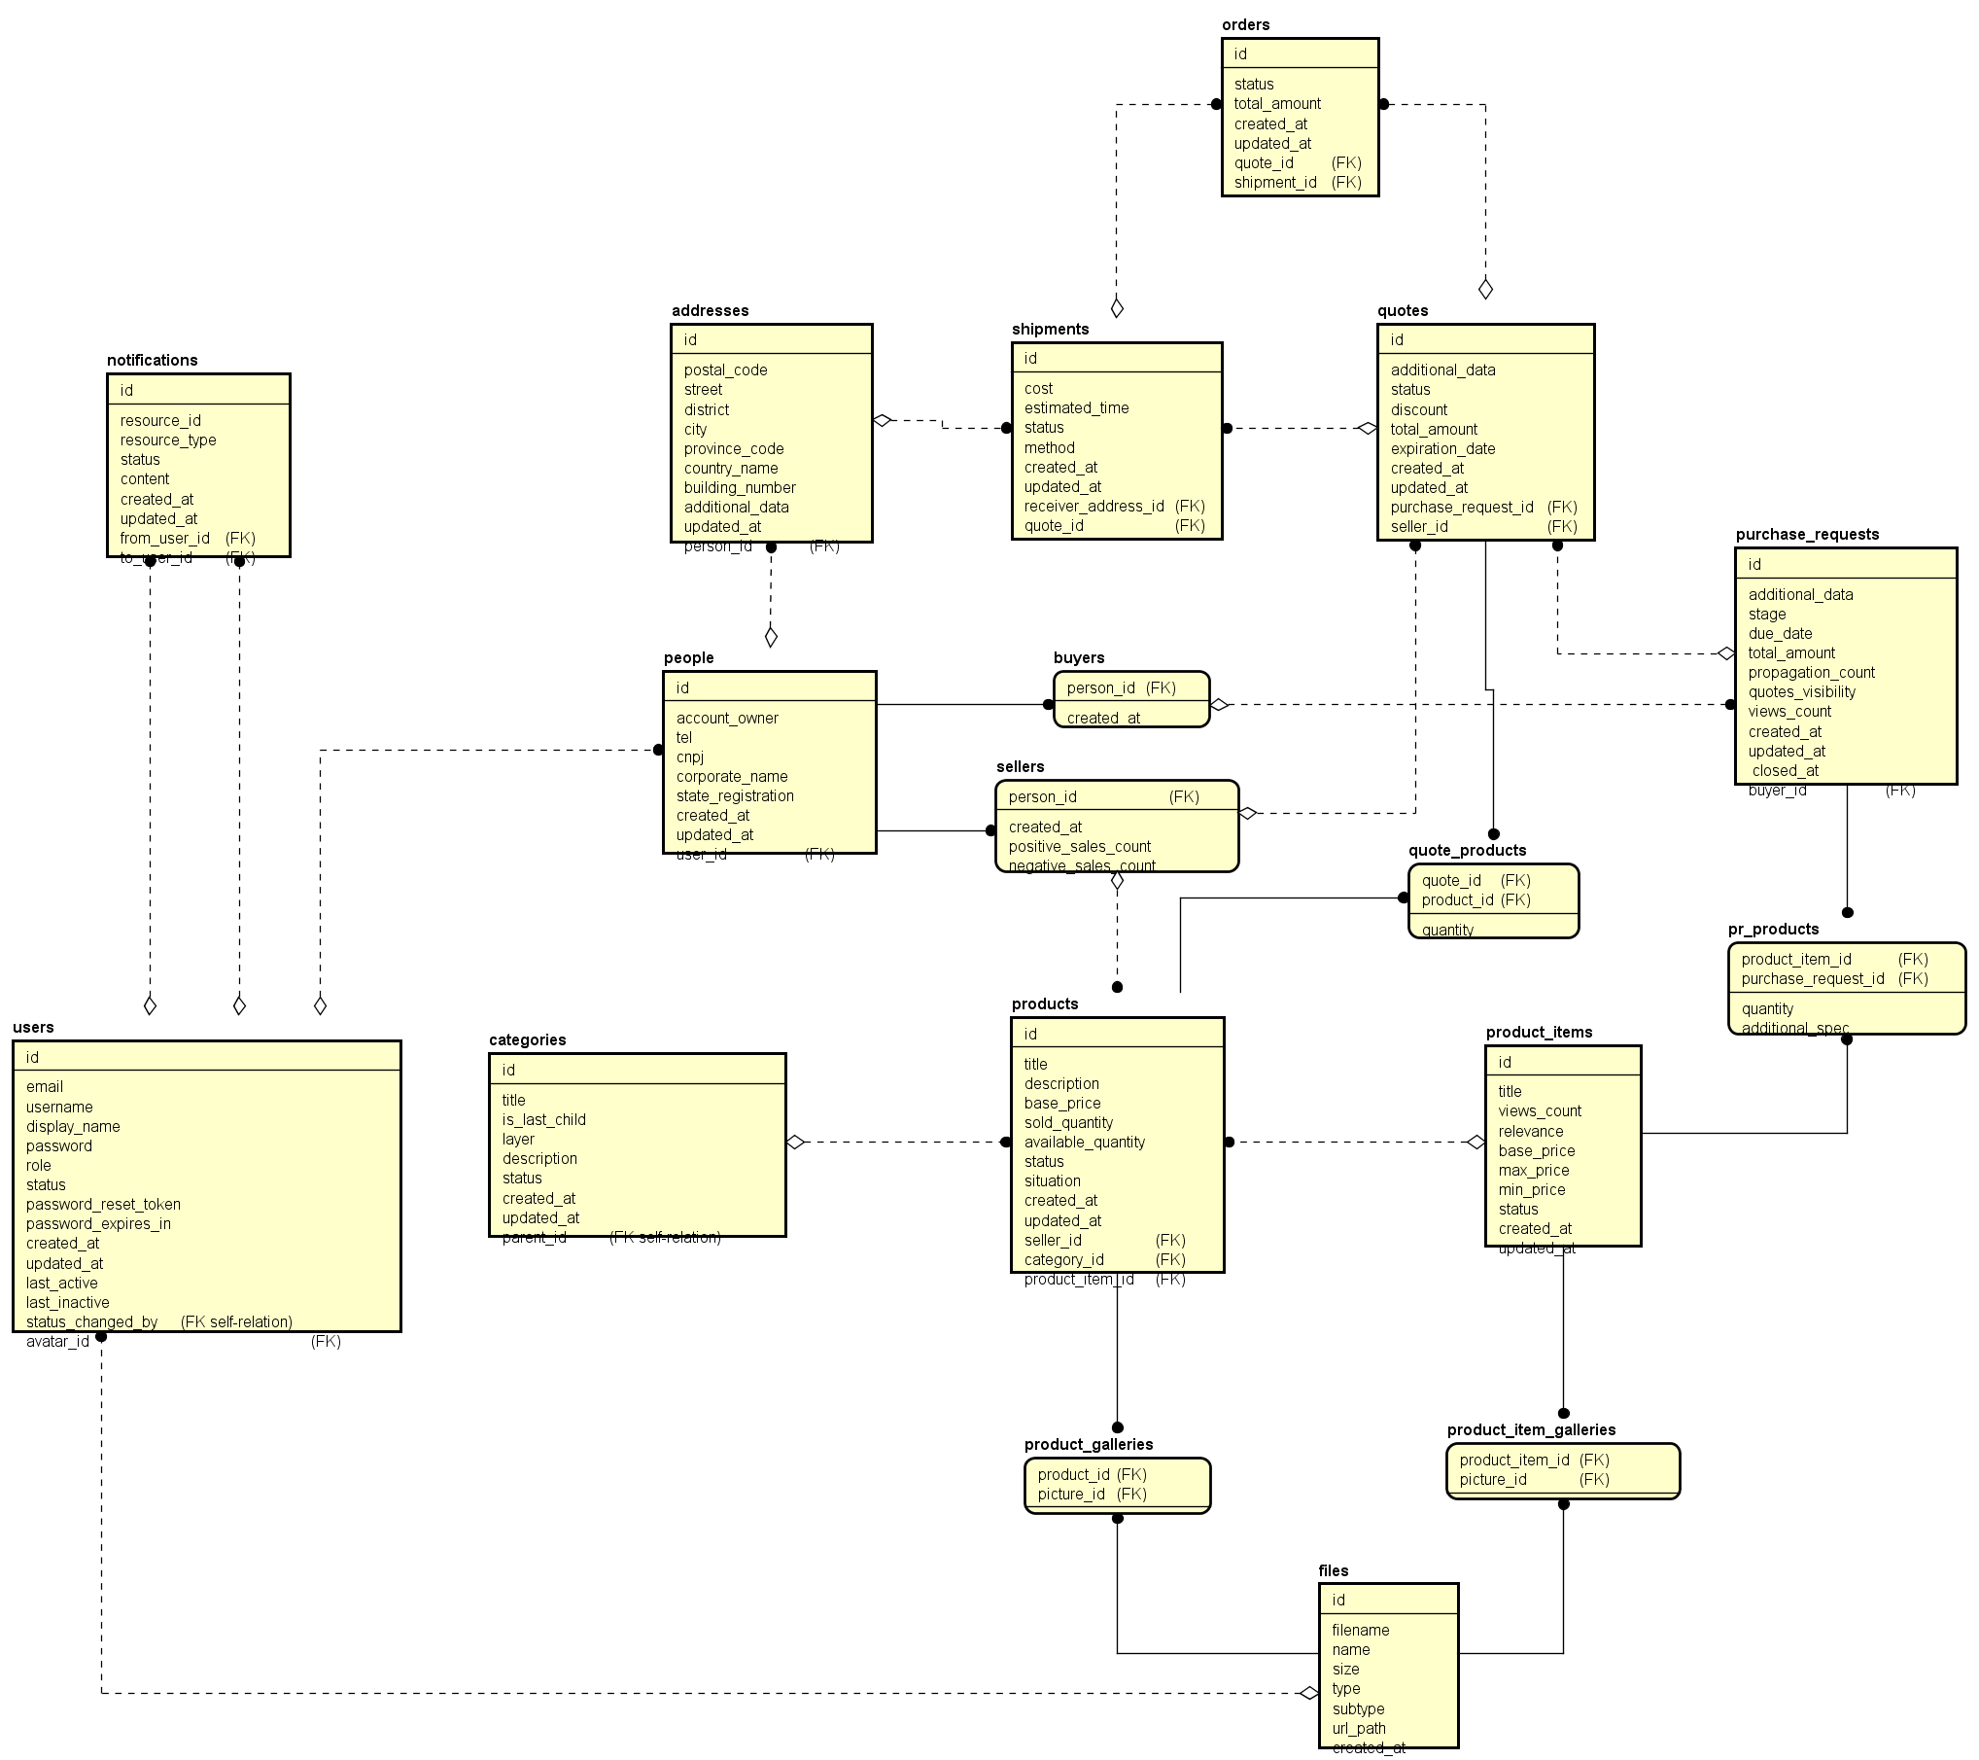

Modelo Relacional

files (
id,
filename,
name,
size,
type,
url_path,
created_at,
updated_at
);

users (
id,
email,
username,
display_name,
password,
role,
status,
password_reset_token,
password_expires_in,
last_active,
last_inactive,
created_at,
updated_at,
status_changed_by,
avatar_id
);

people (
id,
account_owner,
tel,
cnpj,
corporate_name,
state_registration,
created_at,
updated_at,
user_id
);

addresses (
id,
postal_code,
street,
district,
city,
province_code,
country_name,
building_number,
additional_data,
created_at,
updated_at,
person_id
);

buyers (
person_id,
created_at
);

sellers (
person_id,
positive_sales_count,
negative_sales_count,
created_at
);

notifications (
id,
resource_type,
status,
resource_id,
content,
created_at,
updated_at,
from_user_id,
to_user_id
);

categories (
id,
title,
is_last_child,
layer,
description,
status,
created_at,
updated_at,
parent_id
);

product_items (
id,
title,
views_count,
relevance,
base_price,
max_price,
min_price,
status,
created_at,
updated_at
);

product_item_galleries (
product_item_id,
picture_id
);

products (
id,
title,
description,
base_price,
sold_quantity,
available_quantity,
status,
situation,
created_at,
updated_at,
seller_id,
category_id,
produtct_item_id
);

product_galleries (
product_id,
picture_id
);

purchase_requests (
id,
additional_data,
stage,
due_date,
total_amount,
views_count,
propagation_count,
quotes_visibility,
closed_at,
created_at,
updated_at,
buyer_id
);

pr_products (
purchase_request_id,
product_item_id,
quantity,
additional_spec
);

quotes (
id,
additional_data,
status,
discount,
total_amount,
expiration_date,
created_at,
updated_at,
purchase_request_id,
seller_id
);

quote_products (
quote_id,
product_id,
quantity,
sale_price
);

shipments (
id,
cost,
status,
method,
estimated_time,
created_at,
updated_at,
receiver_address_id,
quote_id
);

orders (
id,
status,
total_amount,
created_at,
updated_at,
quote_id,
shipment_id
);

Script de Criação das Tabelas

-- TYPES

CREATE TYPE notification_resource AS ENUM ('PURCHASE_REQUEST', 'QUOTE', 'PAYMENT', 'ORDER');
CREATE TYPE notification_status AS ENUM ('PENDING', 'VIEWED');
CREATE TYPE pr_stage AS ENUM ('CREATION', 'UNDER_QUOTATION', 'CLOSED', 'EXPIRED', 'CANCELED');
CREATE TYPE product_situation AS ENUM ('LINKED', 'UNLINKED');
CREATE TYPE quote_status AS ENUM ('UNDER_REVIEW', 'ACCEPTED', 'DECLINED', 'EXPIRED');
CREATE TYPE shipment_method AS ENUM ('CUSTOM', 'FREE', 'LOCAL_PICK_UP');
CREATE TYPE shipment_status AS ENUM ('HANDLING', 'DISPATCHED_OUT', 'RETURNED', 'DELIVERED');
CREATE TYPE status_entity AS ENUM ('ACTIVE', 'INACTIVE');
CREATE TYPE users_role AS ENUM ('ADMIN', 'MODERATOR', 'COMMON');
CREATE TYPE order_status AS ENUM ('CONFIRMED', 'PAID', 'CANCELED');

-- TABLES

CREATE TABLE files (
id SERIAL NOT NULL PRIMARY KEY,
filename VARCHAR(255) NOT NULL,
name VARCHAR(255) NOT NULL,
size INTEGER NOT NULL,
type VARCHAR(20) NOT NULL,
url_path TEXT NOT NULL,
created_at TIMESTAMP WITH TIME ZONE,
updated_at TIMESTAMP WITH TIME ZONE
);

CREATE TABLE users (
id SERIAL NOT NULL PRIMARY KEY,
email VARCHAR(255) NOT NULL,
username VARCHAR(25) NOT NULL,
display_name VARCHAR(255) NOT NULL,
password VARCHAR(100) NOT NULL,
role users_role NOT NULL,
status status_entity NOT NULL,
password_reset_token VARCHAR(255),
password_expires_in TIMESTAMP WITH TIME ZONE,
last_active TIMESTAMP WITH TIME ZONE,
last_inactive TIMESTAMP WITH TIME ZONE,
created_at TIMESTAMP WITH TIME ZONE,
updated_at TIMESTAMP WITH TIME ZONE,
status_changed_by INTEGER REFERENCES users (id),
avatar_id INTEGER REFERENCES files (id)
);

CREATE TABLE people (
id SERIAL NOT NULL PRIMARY KEY,
account_owner VARCHAR(255) NOT NULL,
tel BIGINT NOT NULL,
cnpj BIGINT NOT NULL,
corporate_name VARCHAR(255) NOT NULL,
state_registration VARCHAR(255) NOT NULL,
created_at TIMESTAMP WITH TIME ZONE,
updated_at TIMESTAMP WITH TIME ZONE,
user_id INTEGER NOT NULL REFERENCES users (id)
);

CREATE TABLE addresses (
id SERIAL NOT NULL PRIMARY KEY,
postal_code VARCHAR(255) NOT NULL,
street VARCHAR(255) NOT NULL,
district VARCHAR(255) NOT NULL,
city VARCHAR(255) NOT NULL,
province_code VARCHAR(255) NOT NULL,
country_name VARCHAR(255) NOT NULL,
building_number INTEGER NOT NULL,
additional_data TEXT,
created_at TIMESTAMP WITH TIME ZONE,
updated_at TIMESTAMP WITH TIME ZONE,
person_id INTEGER NOT NULL REFERENCES people (id)
);

CREATE TABLE buyers (
person_id SERIAL NOT NULL PRIMARY KEY,
created_at TIMESTAMP WITH TIME ZONE,
FOREIGN KEY (person_id) REFERENCES people (id)
);

CREATE TABLE sellers (
person_id SERIAL NOT NULL PRIMARY KEY,
positive_sales_count INTEGER NOT NULL DEFAULT 0,
negative_sales_count INTEGER NOT NULL DEFAULT 0,
created_at TIMESTAMP WITH TIME ZONE,
FOREIGN KEY (person_id) REFERENCES people (id)
);

CREATE TABLE notifications (
id SERIAL NOT NULL PRIMARY KEY,
resource_type notification_resource NOT NULL,
status notification_status NOT NULL,
resource_id INTEGER,
content TEXT,
created_at TIMESTAMP WITH TIME ZONE,
updated_at TIMESTAMP WITH TIME ZONE,
from_user_id INTEGER REFERENCES users (id),
to_user_id INTEGER NOT NULL REFERENCES users (id)
);

CREATE TABLE categories (
id SERIAL NOT NULL PRIMARY KEY,
title VARCHAR(255) NOT NULL,
is_last_child BOOLEAN NOT NULL,
layer INTEGER NOT NULL,
description TEXT,
status status_entity NOT NULL,
created_at TIMESTAMP WITH TIME ZONE,
updated_at TIMESTAMP WITH TIME ZONE,
parent_id INTEGER REFERENCES categories (id)
);

CREATE TABLE product_items (
id SERIAL NOT NULL PRIMARY KEY,
title VARCHAR(255) NOT NULL,
views_count INTEGER NOT NULL DEFAULT 0,
relevance INTEGER NOT NULL,
base_price NUMERIC(15,2) NOT NULL,
max_price NUMERIC(15,2) NOT NULL,
min_price NUMERIC(15,2) NOT NULL,
status status_entity NOT NULL,
created_at TIMESTAMP WITH TIME ZONE,
updated_at TIMESTAMP WITH TIME ZONE
);

CREATE TABLE product_item_galleries (
product_item_id INTEGER NOT NULL,
picture_id INTEGER NOT NULL,
PRIMARY KEY (product_item_id, picture_id),
FOREIGN KEY (product_item_id) REFERENCES product_items (id),
FOREIGN KEY (picture_id) REFERENCES files (id)
);

CREATE TABLE products (
id SERIAL NOT NULL PRIMARY KEY,
title VARCHAR(255) NOT NULL,
description TEXT,
base_price NUMERIC(15,2) NOT NULL,
sold_quantity INTEGER NOT NULL,
available_quantity INTEGER NOT NULL,
status status_entity NOT NULL,
situation product_situation NOT NULL,
created_at TIMESTAMP WITH TIME ZONE,
updated_at TIMESTAMP WITH TIME ZONE,
seller_id INTEGER REFERENCES sellers (person_id),
category_id INTEGER REFERENCES categories (id),
produtct_item_id INTEGER REFERENCES product_items (id)
);

CREATE TABLE product_galleries (
product_id INTEGER NOT NULL,
picture_id INTEGER NOT NULL,
PRIMARY KEY (product_id, picture_id),
FOREIGN KEY (product_id) REFERENCES products (id),
FOREIGN KEY (picture_id) REFERENCES files (id)
);

CREATE TABLE purchase_requests (
id SERIAL NOT NULL PRIMARY KEY,
additional_data TEXT,
stage pr_stage NOT NULL,
due_date TIMESTAMP WITH TIME ZONE NOT NULL,
total_amount NUMERIC(20,5) NOT NULL,
views_count INTEGER NOT NULL DEFAULT 0,
propagation_count INTEGER NOT NULL,
quotes_visibility BOOLEAN NOT NULL,
closed_at TIMESTAMP WITH TIME ZONE,
created_at TIMESTAMP WITH TIME ZONE,
updated_at TIMESTAMP WITH TIME ZONE,
buyer_id INTEGER REFERENCES buyers (person_id)
);

CREATE TABLE pr_products (
purchase_request_id INTEGER NOT NULL,
product_item_id INTEGER NOT NULL,
quantity INTEGER NOT NULL,
additional_spec TEXT,
PRIMARY KEY (purchase_request_id, product_item_id),
FOREIGN KEY (purchase_request_id) REFERENCES purchase_requests (id),
FOREIGN KEY (product_item_id) REFERENCES product_items (id)
);

CREATE TABLE quotes (
id SERIAL NOT NULL PRIMARY KEY,
additional_data TEXT,
status quote_status NOT NULL,
discount NUMERIC NOT NULL,
total_amount NUMERIC(20,2) NOT NULL,
expiration_date TIMESTAMP WITH TIME ZONE NOT NULL,
created_at TIMESTAMP WITH TIME ZONE,
updated_at TIMESTAMP WITH TIME ZONE,
purchase_request_id INTEGER NOT NULL REFERENCES purchase_requests (id),
seller_id INTEGER NOT NULL REFERENCES sellers (person_id)
);

CREATE TABLE quote_products (
quote_id INTEGER NOT NULL,
product_id INTEGER NOT NULL,
quantity INTEGER NOT NULL,
sale_price NUMERIC(15,2) NOT NULL,
PRIMARY KEY (quote_id, product_id),
FOREIGN KEY (quote_id) REFERENCES quotes (id),
FOREIGN KEY (product_id) REFERENCES products (id)
);

CREATE TABLE shipments (
id SERIAL NOT NULL PRIMARY KEY,
cost NUMERIC(10,2) NOT NULL,
status shipment_status NOT NULL,
method shipment_method NOT NULL,
estimated_time DATE,
created_at TIMESTAMP WITH TIME ZONE,
updated_at TIMESTAMP WITH TIME ZONE,
receiver_address_id INTEGER REFERENCES addresses (id),
quote_id INTEGER NOT NULL REFERENCES quotes (id)
);

CREATE TABLE orders (
id SERIAL NOT NULL PRIMARY KEY,
status order_status NOT NULL,
total_amount NUMERIC(30,2) NOT NULL,
created_at TIMESTAMP WITH TIME ZONE,
updated_at TIMESTAMP WITH TIME ZONE,
quote_id INTEGER NOT NULL REFERENCES quotes (id),
shipment_id INTEGER NOT NULL REFERENCES shipments (id)
);

-- INDEXES

CREATE INDEX notifications_created_at ON notifications (created_at);
CREATE INDEX notifications_from_to_users ON notifications (from_user_id, to_user_id);
CREATE INDEX notifications_from_users ON notifications (from_user_id);
CREATE INDEX notifications_status_to_users ON notifications (status, to_user_id);
CREATE INDEX notifications_to_users ON notifications (to_user_id);

CREATE INDEX pr_products_pkey_pi ON pr_products (product_item_id);
CREATE INDEX pr_products_pkey_pr ON pr_products (purchase_request_id);
CREATE INDEX pr_products_pkeys ON pr_products (product_item_id, purchase_request_id);

CREATE INDEX purchase_requests_buyer_stage ON purchase_requests (buyer_id, stage);

CREATE INDEX quote_products_index ON quote_products (quote_id, product_id);

CREATE INDEX quote_id_pr_seller ON quotes (id, purchase_request_id, seller_id);
CREATE INDEX quote_pr_seller ON quotes (purchase_request_id, seller_id);
CREATE INDEX quote_pr ON quotes (purchase_request_id);

-- SEQUENCES

CREATE SEQUENCE pr_sequence START 10000 MINVALUE 10000 OWNED BY purchase_requests.id;

-- FUNCTIONS

CREATE OR REPLACE FUNCTION func_insert_new_category(title varchar(255), description text, layer integer, parent_id integer)
RETURNS void AS $$
DECLARE
title ALIAS FOR $1;
description ALIAS FOR $2;
layer ALIAS FOR $3;
parent ALIAS FOR $4;
status status_entity;
is_last_child BOOLEAN;
BEGIN
status := 'ACTIVE';
is_last_child := true;
INSERT INTO categories ("title", "description", "is_last_child", "layer", "parent_id", "status", "created_at")
VALUES (title, description, is_last_child, layer, parent, status, NOW());

IF parent_id IS NULL THEN
RETURN;
ELSE
UPDATE "categories" SET "is_last_child" = false WHERE "id" = parent;
END IF;
END;
$$ LANGUAGE 'plpgsql';

CREATE OR REPLACE FUNCTION func_toggle_status_categories (categoryId integer, status status_entity) RETURNS void AS $$
DECLARE
categoryId ALIAS FOR $1;
categoryStatus ALIAS FOR $2;
returnedId integer;
rowSelect record;
BEGIN
UPDATE categories SET status = categoryStatus, updated_at = NOW() WHERE id = categoryId RETURNING id INTO returnedId;

IF returnedId > 0 THEN
FOR rowSelect IN SELECT id FROM categories WHERE parent_id = returnedId
LOOP
PERFORM * FROM func_toggle_status_categories(rowSelect.id, categoryStatus);
END LOOP;
END IF;
END;
$$ LANGUAGE 'plpgsql';

CREATE OR REPLACE FUNCTION get_pr_sellers(pr_id integer)
RETURNS TABLE (person_id integer, created_at timestamp with time zone, positive_sales_count integer, negative_sales_count integer)
AS $$
DECLARE
pr_id ALIAS FOR $1;
ppg_duplicated integer[][];
sellers_ids integer[];
pi_count integer;
rec_pr RECORD;
sellers_ids_result integer[];
BEGIN

SELECT COUNT(pr_products.product_item_id)
FROM pr_products
WHERE pr_products.purchase_request_id = pr_id INTO pi_count;

IF pi_count > 0 THEN

FOR rec_pr IN (
SELECT purchase_requests.buyer_id, pr_products.product_item_id, pr_products.quantity
FROM pr_products
INNER JOIN purchase_requests
ON purchase_requests.id = pr_products.purchase_request_id
WHERE pr_products.purchase_request_id = pr_id
) LOOP
SELECT ARRAY(
SELECT products.seller_id
FROM product_items
INNER JOIN products
ON product_items.id = products.product_item_id
INNER JOIN sellers
ON products.seller_id = sellers.person_id
INNER JOIN people
ON sellers.person_id = people.id
INNER JOIN users
ON people.user_id = users.id
WHERE products.status = CAST('ACTIVE' AS status_entity)
AND users.status = CAST('ACTIVE' as status_entity)
AND products.product_item_id = rec_pr.product_item_id
AND products.available_quantity >= rec_pr.quantity
AND rec_pr.buyer_id <> sellers.person_id
) INTO sellers_ids;

SELECT ppg_duplicated || sellers_ids INTO ppg_duplicated;

END LOOP;

SELECT ARRAY(
SELECT UNNEST(ppg_duplicated) GROUP BY 1 HAVING COUNT(*) = pi_count
) INTO sellers_ids_result;
END IF;
RETURN QUERY SELECT s.person_id, s.created_at, s.positive_sales_count, s.negative_sales_count
FROM sellers AS s WHERE s.person_id = ANY(sellers_ids_result::integer[]);
END;
$$ LANGUAGE 'plpgsql';

CREATE OR REPLACE FUNCTION pr_update_views(pr_id integer)
RETURNS void AS $$
DECLARE
pr_id ALIAS FOR $1;
final_views_count integer;
row_select record;
BEGIN
FOR row_select IN SELECT views_count FROM purchase_requests WHERE id = pr_id
LOOP
final_views_count := row_select.views_count + 1;
UPDATE purchase_requests SET views_count = final_views_count WHERE id = pr_id;
END LOOP;
END;
$$ LANGUAGE 'plpgsql';

